|  |  |  |  |  |  |  |
| --- | --- | --- | --- | --- | --- | --- |
| Description: Vertical full colour positive | Safety Bay Senior High School | | | | | |
| **CHEMISTRY UNIT 3 & 4** | | | | | | |
| **Biodiesel Investigation:** | | | | | | |
| **Validation Test** | | | | | | |
|  | | | | | | |
| **NAME:** | | | **ANSWERS** | | | |
|  | | |  | | | |
| **Time allowed for this paper** | | | | | | |
| Reading time: | | 5 minutes | | | | |
| Working time: | | 50 minutes | | | | |
|  | | | | | | |
| **Structure of this paper:** | | | | | | |
| Section | | | Number of questions | Marks available | | Marks achieved |
| Short Answer | | |  |  | |  |
|  | | |  | | **Total** | ______ / 44 |

Canola is Australia’s third-largest grown crop behind wheat and barley. Western Australia produces 40% of all canola nationwide. A majority of this canola is exported to Asia and Europe. The predominant use of canola has been for its edible oil, however it is becoming increasingly important as a source for biodiesel.

The following image shows the chemical structure of canola oil:

C

B

A

H

H

H

H

H

C

C

C

C

(CH2)7

(CH2)7

CH3

O

O

H

H

C

C

H

H

C

C

C

(CH2)7

(CH2)7

CH3

O

O

C

(CH2)7

O

O

H

H

C

C

C

H

H

H

H

C

C

(CH2)4

CH3

The production of biodiesel can be achieved through base-catalysed transesterification with methanol.

1. While petroleum diesel and biodiesel are produced differently, they have similar structures to each other. The condensed structure of a petroleum diesel is given here.

CH3 ─ CH2 ─ (CH2)12 ─ CH2 ─ CH3

1. Draw the condensed structure of a biodiesel produced from the chain labelled **A** in the diagram above. The alcohol used in the reaction was methanol. (3 marks)

|  |  |
| --- | --- |
| Structure contains a methyl ester functional group | 1 |
| Structural diagram CH3-O-CO-(CH2)7­-CH=CH-(CH2)7-CH3 | 2 |
| Diagram has one minor omission | 1 |

1. Describe the difference between the structure of biodiesel and the structure of petroleum diesel. (1 mark)

Biodiesel is a methyl ester of a fatty acid, whereas petrodiesel does not contain an ester group.

1. Due to the slow rate of the transesterification reaction, a catalyst (usually NaOH or KOH) is used. Explain the role of the catalyst in the reaction. (3 marks)

* **A catalyst increases the rate of the reaction by**
* **providing an alternative reaction pathway with a lower Ea**
* **thereby allowing greater proportion of particles to overcome Ea barrier**

1. To prevent different products forming in an alternative synthesis pathway, the quantity of sodium hydroxide catalyst present in the reaction must be kept low, compared with the canola oil. If the mole ratio of NaOH to canola oil approaches the ratio 3:1, the alternative pathway becomes significant.
2. What type of organic product forms in this alternative pathway? (1 mark)



1. Draw the structure for one organic product that forms in the alternative synthesis pathway from this canola oil. (1 mark)

|  |  |
| --- | --- |
| Sodium salt of a long chain fatty acid component of A, B or C o**r** | 1 |
| glycerol | 1 |
|  |  |

1. The transesterification of canola oil requires a molar ratio of 3 moles of methanol to 1 mole of oil. In practice, however, a ratio of 6:1 methanol to oil is more commonly used. Explain the effect of the increased ratio on the yield of biodiesel. (3 marks)

* **Increasing the concentration of methanol results in more collisions between reactants.**
* **This increases the rate of forwards reaction**
* **This shifts the equilibrium to the right and produces a higher yield of biodiesel**

1. A temperature of approximately 50°C is used during the synthesis of biodiesel. Explain, in terms of rate and yield, why this temperature is selected. (4 marks)

* **An increase in temperature increases the rate of reaction**
* **However, methanol has a relatively low boiling point and above 50**°**C begins to evaporate**
* **Therefore removing a reactant and reducing the yield or increasing saponification and decreasing yield**
* **Therefore a compromise temperature of 50°C is used.**

1. When the biodiesel is produced a second molecule is produced.
2. Draw and name the molecule. (2 marks)

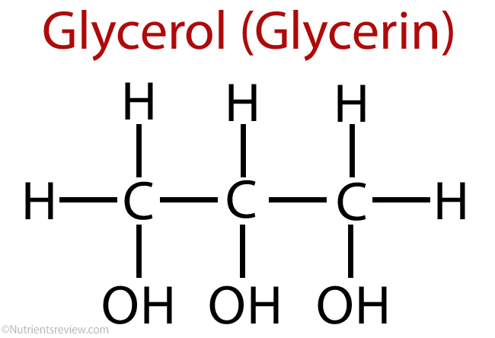 Glycerol (or propane-1,2,3-triol)

1. At the conclusion of the transesterification reaction, two liquid layers can be observed: a pale yellow, cloudy liquid forming the top layer and a darker liquid in the bottom layer.

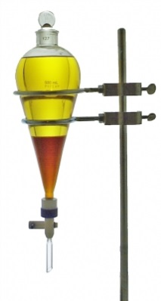

Other than water, name one substance that would be found in the dark bottom layer. Justify your answer. (2 marks)

* **Catalyst (NaOH or KOH)/alcohol/glycerol**
* **Because NaOH/KOH is polar it will form ion-dipole bonds with glycerol but not with the non-polar biodiesel**
* Methods for producing biodiesel frequently recommend “washing” the product with distilled water to remove impurities. Suggest two impurities that this method is likely to remove. Justify why this impurities are likely to remain and explain why washing with water is a suitable way to remove them. (3 marks)

|  |  |
| --- | --- |
| **2 of the following**   * **Catalyst because it is not consumed during the reaction** * **remaining methanol – because it was in excess** * **glycerol – can remain emulsified in biodiesel layer** | 2 |
| **These impurities are polar and will therefore dissolve in water** | 1 |

1. The following information is from a research paper related to biodiesel production.

**Abstract**

This research is concerned with the conversion of waste palm oil to fatty acid methyl esters (biodiesel) by method of trans-esterification with methanol in the presence of sodium hydroxide or potassium hydroxide catalyst (and their combination in varied proportions). For reaction time of 90 minutes at a reaction temperature of 60 °C and catalyst weight of 1 gram, it was observed that a maximum yield of 94.8% was obtained from palm oil at a methanol to oil mole ratio of 10:1. All biodiesel samples were tested according to ASTM B100 standards to ascertain their properties as commercially usable biodiesel, and all samples were found to comply with the standards.

**Methods**

Measured quantities of catalyst were dissolved in methanol to form a clear solution of potassium/sodium methoxide and the mixture was then added to the heated oil. The content was enclosed, continuously stirred at 300 rpm and maintained at 60 °C for 90 minutes through the use of digital magnetic stirring hotplate. At the end of the transesterification reaction, products obtained were poured into a separating funnel and allowed to settle for 24 hours.

The two products obtained were separated (the top layer was biodiesel and the bottom layer was glycerol). The bottom glycerol layer was first drained off and the top biodiesel layer was made purified by the addition of warm distilled water. Washing was repeated with distilled water until the water obtained from the separating funnel was clean. The pure but wet biodiesel was dried in an oven at 100 °C for 10 minutes.

**Results**

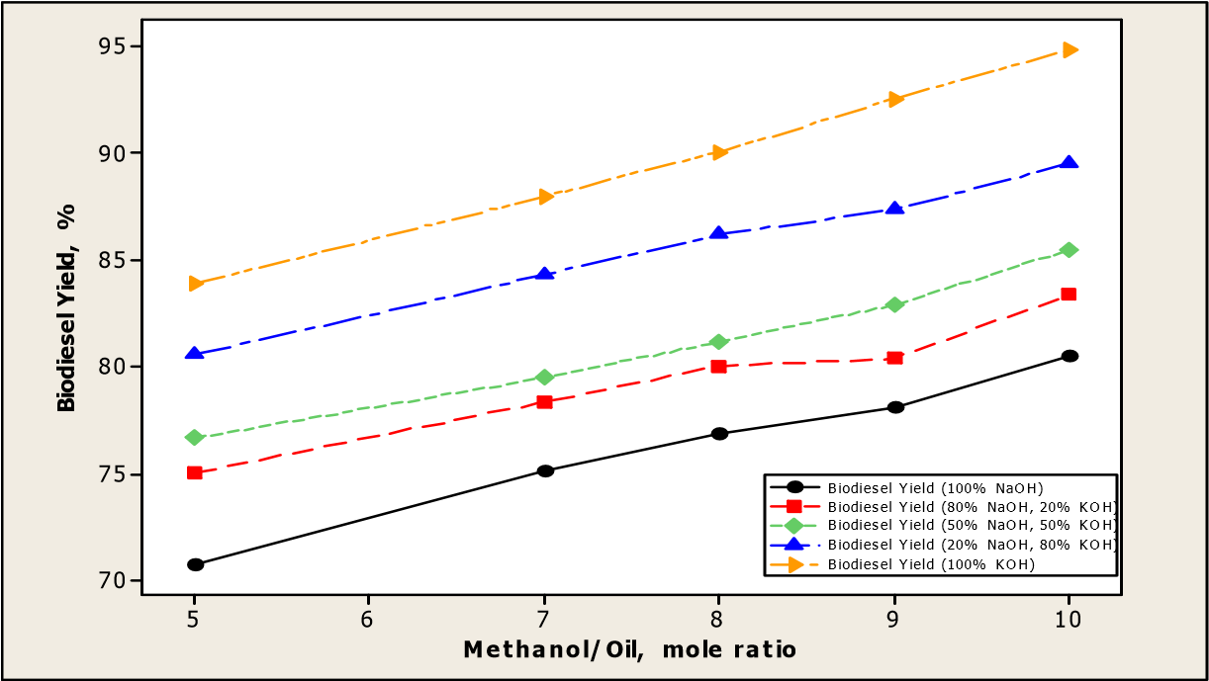

**Figure 2:** Biodiesel obtained from palm oil at different methanol/oil mole ratio and catalyst mixture

1. Identify the independent and dependent variable(s) in this investigation. (2 marks)

|  |
| --- |
| Independent:  **methanol/oil ratio AND NaOH/KOH ratio *(need both IVs for 1 mark)*** |
| Dependent:  **yield of biodiesel** |

1. Discuss the effect of catalyst type on the yield of biodiesel. (5 marks)

* **Describes relationship between yield and catalyst type eg The yield increased with increasing amounts of KOH/decreasing amounts of NaOH**
* **A particular catalysts does not affect yield**
* **…because it affects forward and reverse reaction rates equally**
* **However, yield of biodiesel is affected by the type of catalyst present because NaOH can participate in saponification/the unwanted side reaction by reacting with the fatty acids to form soap, instead of biodiesel**
* **Thus reducing the yield**

1. Suppose the researchers did not dry the wet biodiesel in the final step of the method. Identify how this would affect the results from the experiment, and identify whether this is an example of a random or systematic error. Explain. (3 marks)

**The calculated biodiesel yield would be higher than the actual biodiesel yield (because water would contribute to the measured mass of product)**

**Assuming that the researchers followed a consistent procedure, this would be a systematic error**

**…as it would always affect the results in the same direction (always results in a higher calculated yield – never a lower calculated yield)**

1. To ensure that the levels of soap in commercial biodiesel are not too high, a ‘soap test titration’ is performed once a batch of biodiesel is produced. An acceptable level of purity requires the soap content of the biodiesel to be no higher than 41 ppm (parts per million).To perform this titration, a sample of biodiesel is dissolved in pure isopropyl alcohol. Bromophenol blue indicator is added and a blue colour should be observed. The biodiesel is then titrated against a standard solution of hydrochloric acid (HCℓ) until a colour change from blue to yellow is observed. The titration equation is given below.

C17H33COONa(aq) + HCℓ(aq) → C17H33COOH(aq) + NaCℓ(aq)

A 60.00 mL sample of a particular batch of biodiesel was taken and made up to 150.0 mL with pure isopropyl alcohol. 35.00 mL aliquots were then titrated against a standard 1.65 x 10-4 mol L-1 hydrochloric acid solution, requiring an average of 8.83 mL for equivalence. If the density of the biodiesel is 0.833 g mL-1

1. determine the soap content of this biodiesel sample in parts per million (ppm) and state whether or not the soap content is at an acceptable level for sale. (7 marks)

**n(HCl) = cV**

**= 1.65x10-4 x 0.00883**

**= 1.45695 x 10-6 mol**

**n(soap in 35 mL aliquot) = n(HCl)**

**= 1.45695 x 10-6 mol**

**n(soap in 150 mL) = 1.45695 x 10-6 / 35 x 150**

**= 6.24407 x 10-6 mol**

**= n(soap in 60 mL biodiesel)**

**m(soap) = nM**

**= 6.24407 x 10-6 x 304.434**

**= 0.0019009 g**

**= 1.9009 mg**

**m(biodiesel) = ρV**

**= 0.833 x 60**

**= 49.98 g**

**= 0.04998 kg**

**ppm = mg soap / kg biodiesel**

**= 1.9009 / 0.04998**

**= 38.0 ppm (3SF)**

**soap level is just below 41 ppm - yes, acceptable level for sale**

Current research is focussing on alternate catalysts for biodiesel manufacture, and one of the most promising candidates is the enzyme lipase. When lipase is used to catalyse the transesterification reaction, this prevents the alternate reaction pathway from occurring.

1. Describe what an enzyme is and explain why enzymes are able to minimise the occurrence of unwanted side reactions. (4 marks)

**enzymes are proteins (½) which act as biological catalysts (½)**

**they speed up the rate of a reaction (½) by providing an alternative reaction pathway with a lower Ea (½)**

**enzymes function due to their very specific protein shape (½), through a ‘lock and key’ mechanism (½) (description of model is also acceptable)**

**this means they often only catalyse a single reaction type, therefore eliminating the possibility of unwanted side reactions (1)**